Testing Summary of the FIReTIP Laser

Contents

2. The testing for FIR laser 2

2.1. The setup and alignment of the FIR laser 2

2.2. The optimal methanol gas pressure and the power of the FIR laser 2

2.3. The relationship between FIReTIP laser gas power and CO2 cavity scanning 3

2.4. The relationship between FIR laser and FIR cavity scanning 3

2.5. The beam profile of FIR laser and its parameters 4

3. Testing for combining system of FIR laser and Stark laser 5

3.1. The setup and power of each laser 5

3.2. The relationship between Stark laser and Stark cavity scanning 5

3.3. The beam profile of the stark laser 6

3.4. The optimal pressure and power of the combined lasers 6

3.4.1. The optimal methanol gas pressure and power of FIR laser 6

3.4.2. The optimal methanol gas pressure and power of Stark laser 7

3.5. The unfinished testing for FIReTIP laser system 7

# The testing for FIR laser

## The setup and alignment of the FIR laser

After aligning the FIR laser with the CO2 laser, the beam profile of the CO2 laser in front of the output window of the FIR laser is shown in Figure 1 (a). The optical system between co2 laser and the FIR laser is shown in Figure 1 (b).

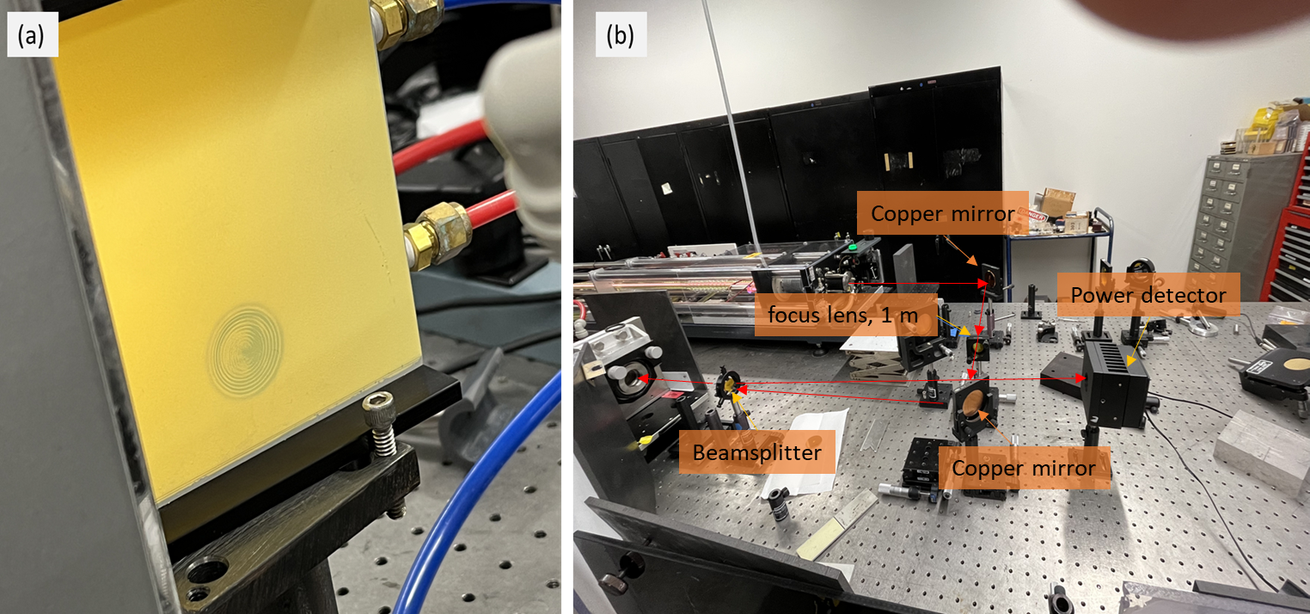

Figure . (a)CO2 laser beam profile in front of the output window of the FIR laser. (b) The optical system between CO2 laser and FIR laser.

## The optimal methanol gas pressure and the power of the FIR laser

For a 150 W CO₂ laser input, the optimal methanol gas pressure for the FIR laser is about 18 mTorr, and the power of FIR laser at 2.5 THz is about 185 mW.

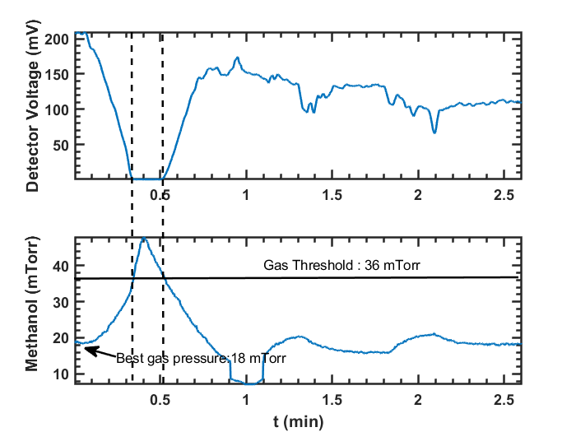

Figure . The relationship between output power and gas pressure shows that the optimal pressure is around 18 mTorr, while the threshold is approximately 36 mTorr.

## The relationship between FIReTIP laser gas power and CO2 cavity scanning

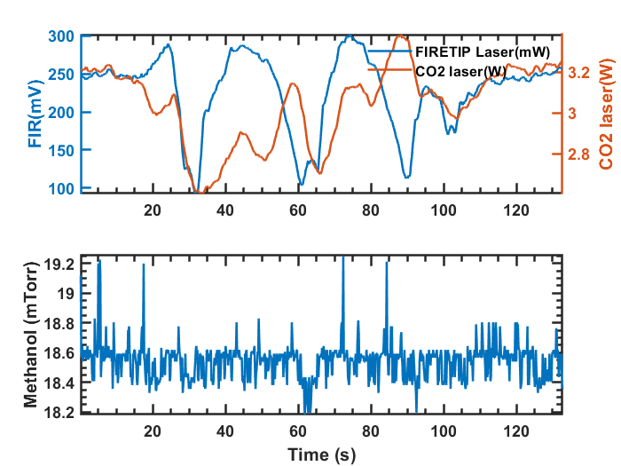

Figure . FIR laser power during CO₂ laser cavity scanning

The FIR laser output power is very sensitive to the cavity adjustment of CO2 laser. Even after about 2 hours of the CO2 laser running, it should be also adjusted about every hour.

## The relationship between FIR laser and FIR cavity scanning

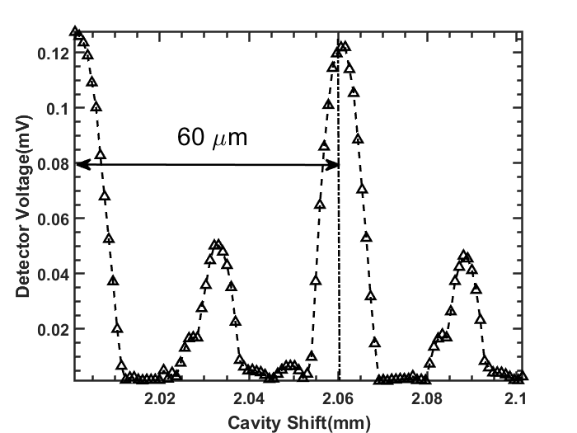

Figure . FIR laser power with cavity scanning

The peak to peak distance is about half wavelength of FIR laser, which is about 119 $μm$.

## The beam profile of FIR laser and its parameters

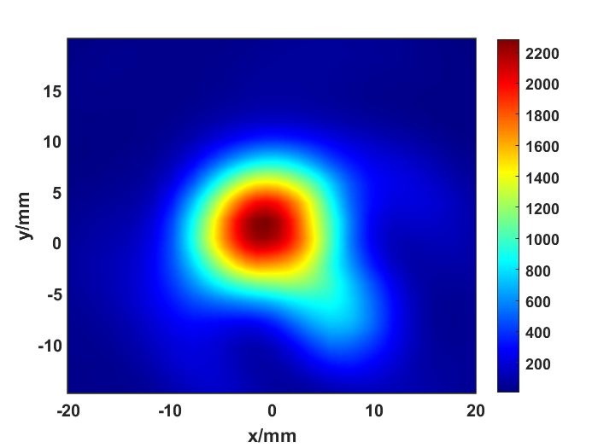

Figure .The beam profile of the FIR laser at z = 73 cm.

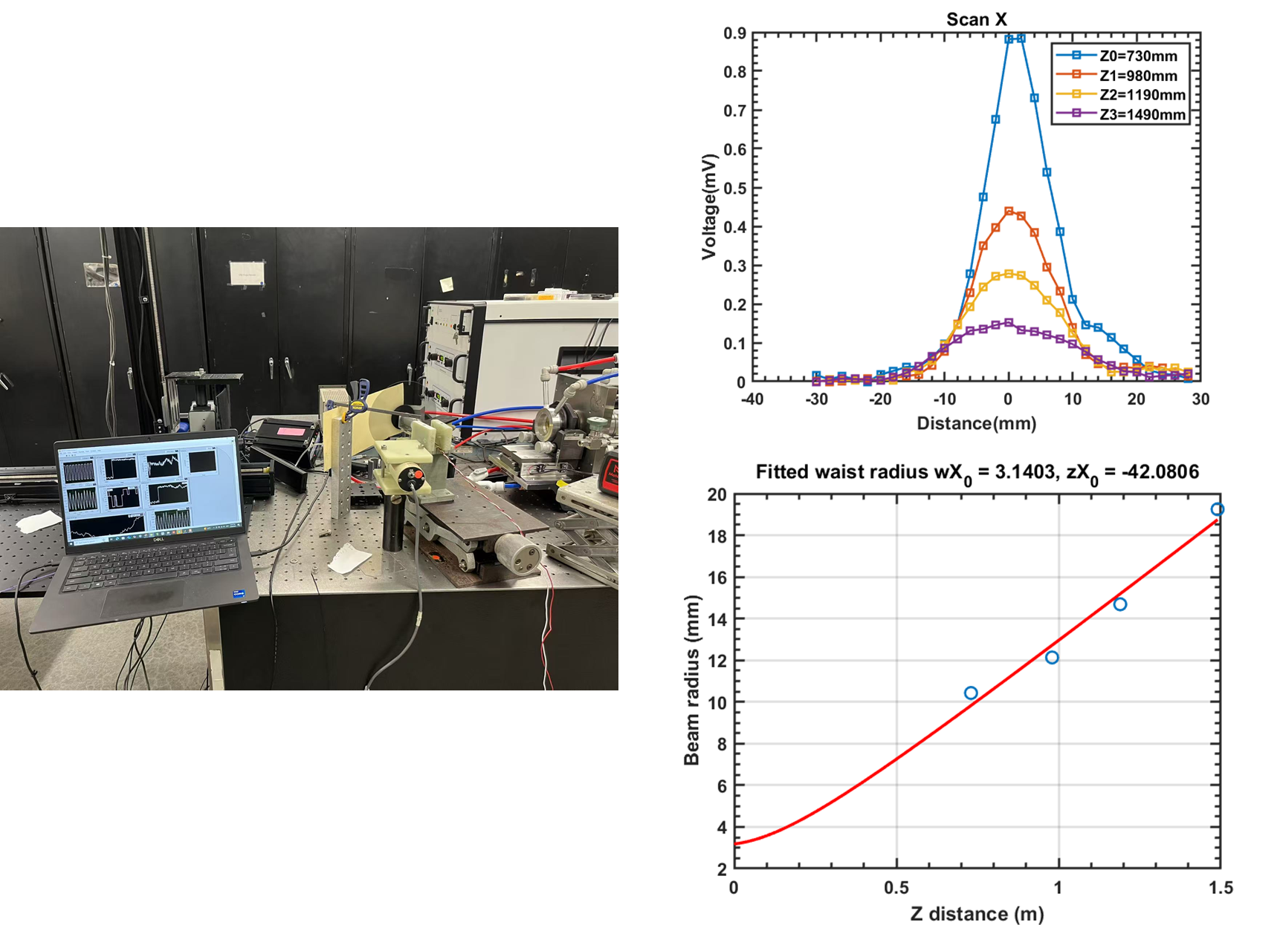

Figure . Measurement setup(left). Beam profile at different z position, where z is the distance from the detector to the output window.

# Testing for combining system of FIR laser and Stark laser

## The setup and power of each laser

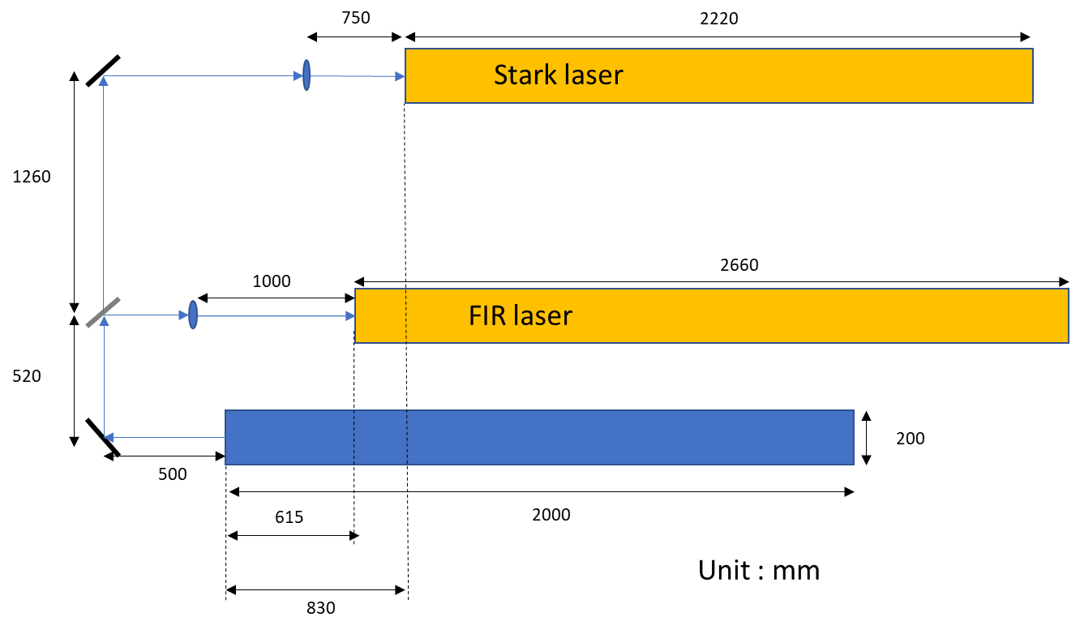

Figure .The setup of the combining system with FIR and Stark laser.

The CO₂ laser was divided equally between the Stark and FIR systems, supplying about 70 W to each. The FIR laser yielded approximately 70 mW, while the Stark laser produced about 10 mW, which was sufficient for the experiment.

## The relationship between Stark laser and Stark cavity scanning

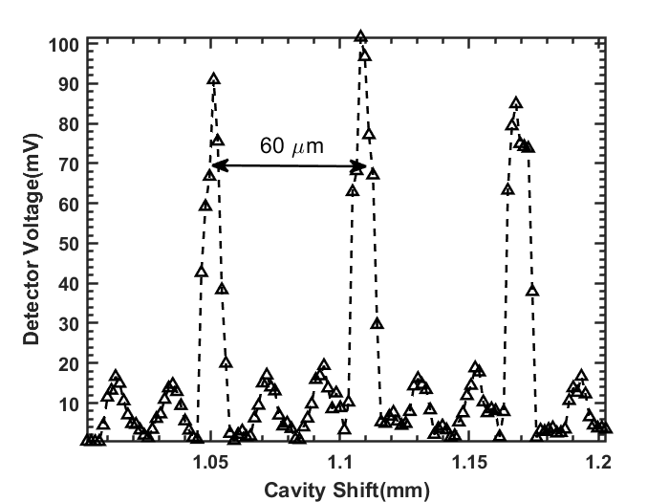

Figure .FIR laser power with cavity scanning

## The beam profile of the stark laser

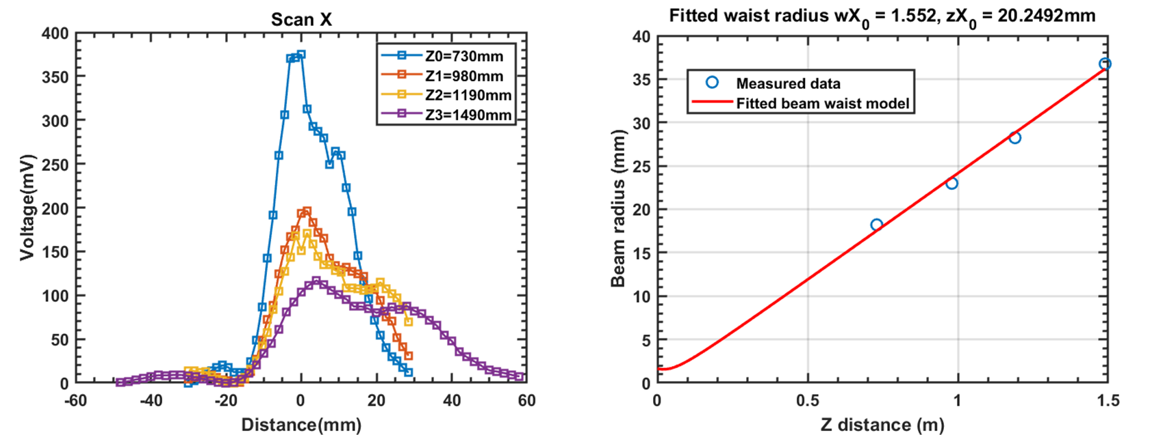

Figure . Data from SCAN_TEST_2D_08_19_2025_00-03

The beam profile of stark laser is shown in Figure 9, with a beam waist radius of about 1.6 mm, located at the front of the output window about 20.2 mm. Here Z refers to the distance from the measured position to the output window.

## The optimal pressure and power of the combined lasers

### The optimal methanol gas pressure and power of FIR laser

With a 70 W CO₂ laser input to a single FIR laser, the optimal gas pressure is approximately 1 mTorr, as shown in Figure 10, at which the maximum FIR output power reaches about 67 mW.

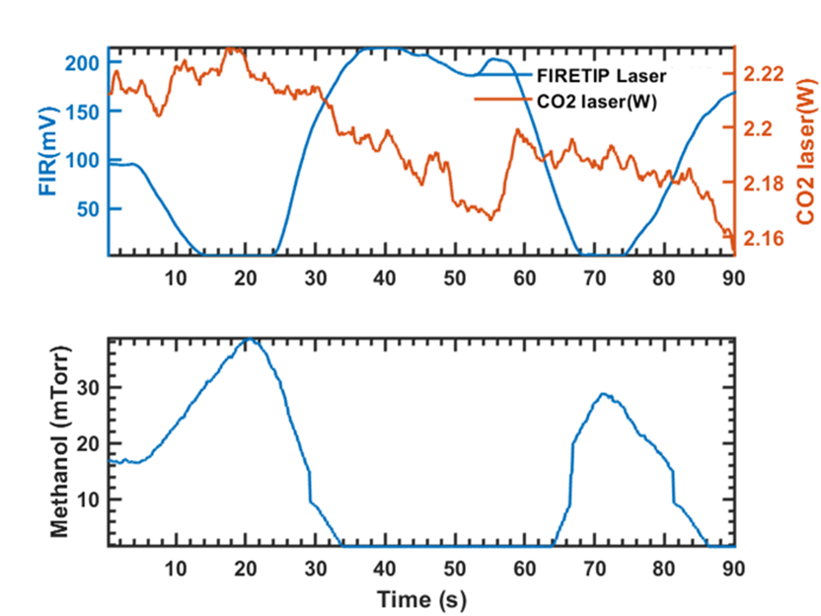

Figure . Scanning the gas pressure while monitoring the FIR laser.

### The optimal methanol gas pressure and power of Stark laser

While for Stark laser system with 70 W CO2 laser input, as shown in Figure 11, the optimal gas pressure is approximately in the range of 60-80 mTorr, at which the maximum Stark output power is about 10 mW.

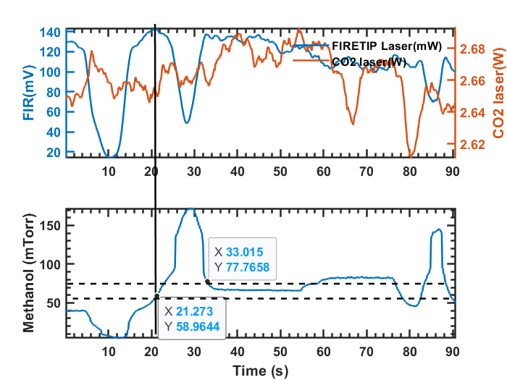

Figure .Scanning the gas pressure while monitoring the Stark laser.

## The unfinished testing for FIReTIP laser system

During frequency-shift testing with the mixer, however, the pump failed to achieve the required pressure. After the experiment, the cavities remained below atmospheric pressure, and within two days both became contaminated by cooling water due to the leaking of the Stark laser.